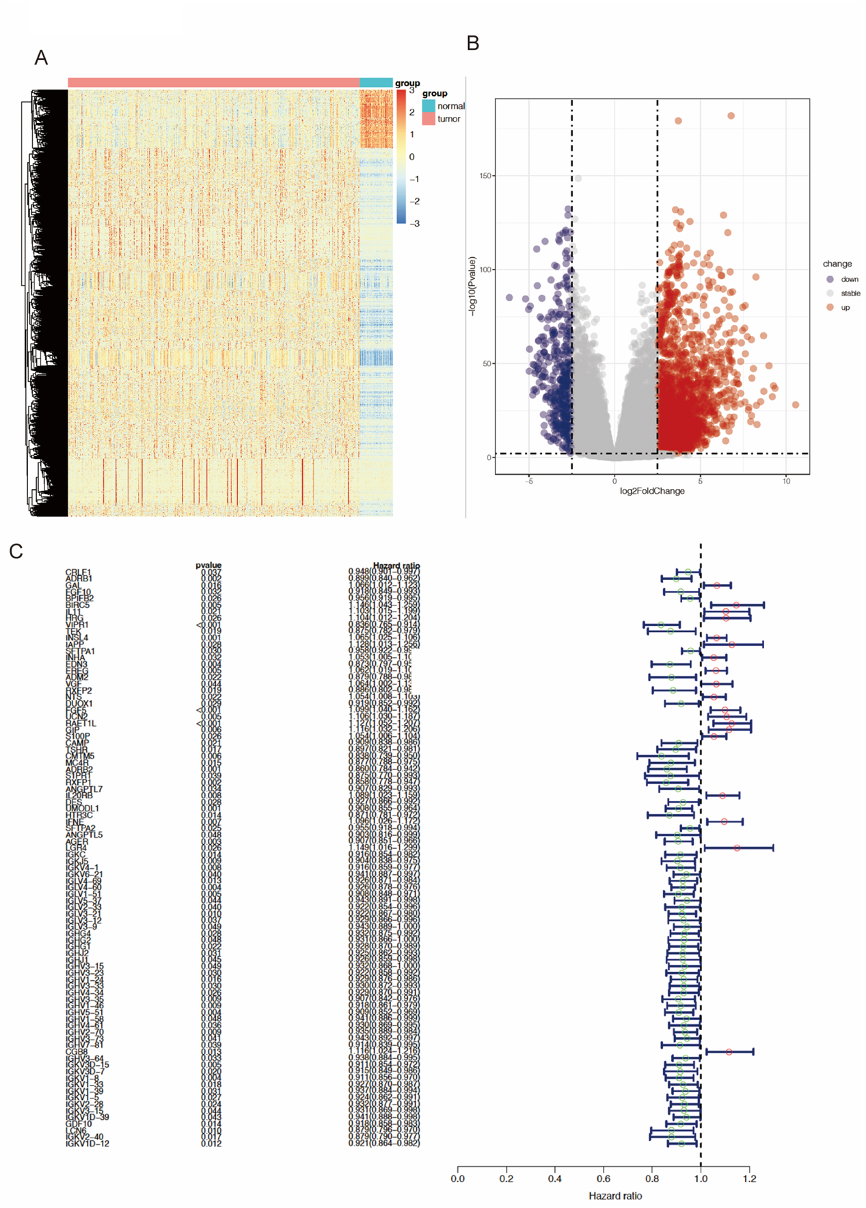
Supplementary Fig. 1. Differential expression analysis and prognostic gene screening. (A,B) Volcano plots and heatmaps showing differentially expressed genes (DEGs) in LUAD compared with normal tissues. (C) Univariate Cox regression analysis identified 88 genes significantly associated with patient survival.

